To access the network drive on your Mac computer, please follow these directions:

The network drive is accessed via the “Finder” application.. To access the “Finder” application, either click on the Finder app in your system tray,

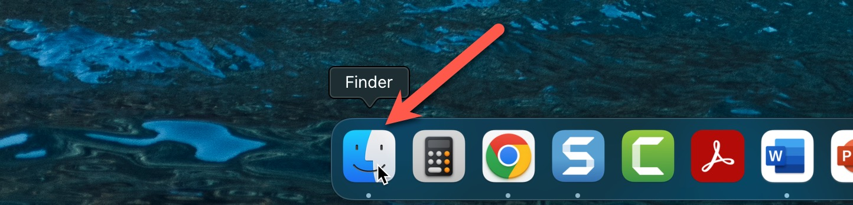

or click on your desktop until “Finder” appears in the “Menu” bar (see yellow arrow in image below)..

To connect to the Network Drive, click on the “Go” tab in the Finder app (see red arrow in image below) and go down to “Connect to Server” (see purple arrow in image below) and click.

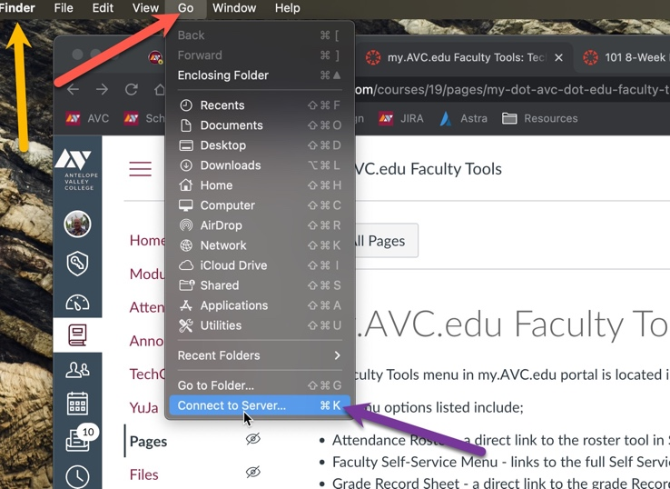

In the dialog box that opens up, type in the following (using no quotes). “smb://avcfiles.avc.edu/UserDocs” (see green arrow in image below)

Click on the “+” sign (red arrow) to add the network address to your favorites..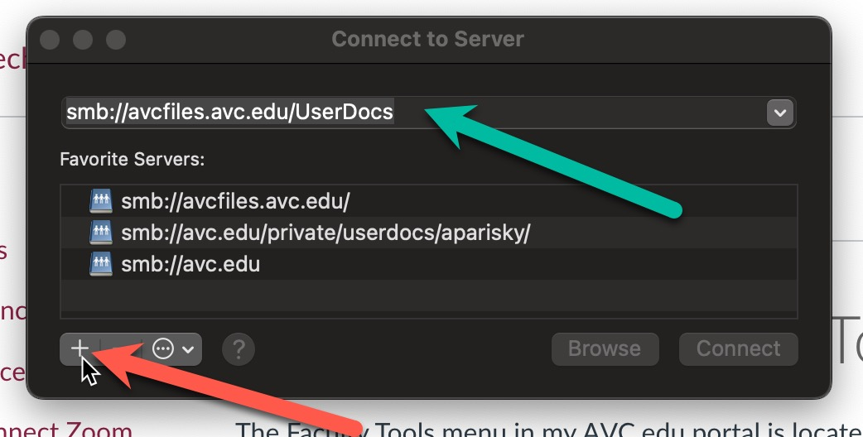

To connect to the saved server, click and highlight the server you want to connect to (see red arrow in image below). Click connect (see pink arrow in image below)…

You will login using your AVC credentials
Username (without @avc.edu)
Password (your single sign-on password)
