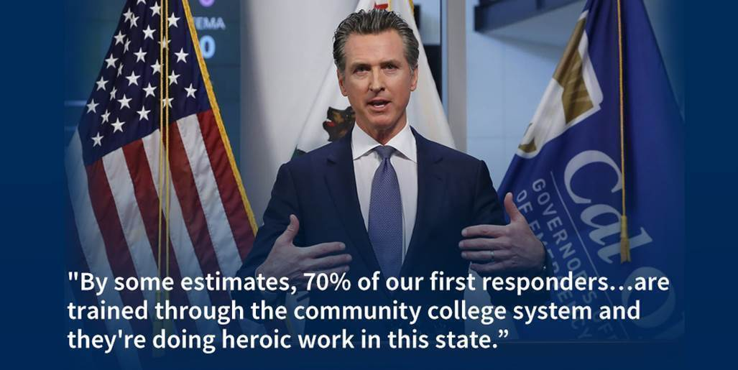

STATE AND NATIONAL GUIDANCE/EXECUTIVE ORDERS

The Senate is set to vote today on a $2 trillion aid package to help stabilize American households and businesses. The bill includes direct payments of $1,200 or less to most adults, loans to businesses and an expansion of unemployment insurance. The House is expected to take it up Thursday at the earliest. The bill is also expected to give colleges and students more than $13 billion in relief and would suspend the payment of federal student loans until September 30.

The U.S. has ordered a 60-day freeze on overseas troop movement due to pandemic. All U.S. service members overseas or scheduled to deploy will stay in their current locations.

Gov. Newsom announced today that several major banks and other financial institutions have agreed to delay foreclosures and provide mortgage relief to California homeowners struggling to make their monthly payments during the pandemic. You can watch the full news conference here (please note: the video starts at about the 6:10 mark).

On Tuesday the governor issued an executive order directing the California Department of Corrections and Rehabilitation to temporarily halt the intake and/or transfer of inmates and youth into the state’s 35 prison facilities and four youth correctional facilities. Read the full executive order here.

The state has launched a website to provide useful COVID-19 information to all residents. It highlights critical steps people can take to stay healthy and includes public service announcements from state health leaders. The website can be found here.

SYSTEM GUIDANCE

The COVID-19 pandemic has changed California’s budget outlook for 2020-21. While the state goes into this period with significant budget reserves, state leaders will be looking to make sensible choices to protect the long-term fiscal health of our state. The Department of Finance on Tuesday released a memo indicating the need to reassess its spending priorities to focus on core operations, often referred to as workload budgets. As we prepare for the 2020-21 May Revision, the Chancellor’s Office is in continuous communication with the Governor’s Office, Department of Finance and Legislative leaders. Our priority and focus is a California Community Colleges budget that invests in the fundamental needs of our students and districts. Key priorities include investments in and protection of funds for existing obligations, funding for cost-of-living adjustments (COLA), and other resources to keep pace with growing costs without compromising the quality of education as we transition to online instruction.

The Chancellor's Office is committed to providing resources to support individual community colleges and their students that are now working online only. The Chancellor’s Office COVID-19 Resources page has updates, guidance and several common questions and answers for students, faculty and staff. Please encourage everyone to routinely check this page, as it will be updated daily.

ONLINE INSTRUCTION
Our partners at SDSU, Dr. Frank Harris III and Dr. Luke Wood, are sponsoring a webinar: Equity-Minded Online Teaching Practices. The goal is to help faculty and staff design online instruction with equity in mind. The webinar will be tomorrow, March 26, at 10:00 am. You can register at this link.
The California Virtual Campus-Online Education Initiative has developed an Emergency Preparedness Resources web site for assistance converting in-person classes to online. Several webinars are scheduled to help during this transition. (Please note: Recordings will be posted afterward for people who are unable to attend).
The California Community Colleges Accessibility Center is hosting another set of webinars this week focusing on accessibility practices for Canvas and online teaching. The final two sessions are tomorrow, one from 10:00 – 11:00 a.m. and another from 3:00 – 4:00 p.m. All sessions will use the same Zoom meeting information.

STUDENT SUPPORTS
Many people are experiencing high levels of fear and anxiety right now, and those feelings are often amplified for anyone who has a mental illness. The National Institute of Mental Health put together resources on coping with stress during the COVID-19 pandemic.
If you or someone you know is struggling with mental health or suicidal thoughts, please call the National Suicide Prevention Lifeline at 800-273-8255 or text the Crisis Text Line at 741741.
The Evergreen Valley College Associated Student Government (ASG) has set aside $16,000 to offer a limited amount of emergency grants - up to $500 each - to help the most vulnerable students with basic needs resources as they continue to navigate through both the Santa Clara County and California "Shelter in Place" Orders. For eligibility criteria and to apply, click on this link.
Not all younger people are following stay-at-home orders or realize the severity of the pandemic. As such, several celebrities and athletes are trying to help promote the message. Golden State Warriors star Stephen Curry is hosting a Q&A with Dr. Anthony Fauci of the National Institute of Allergy and Infectious Diseases. The conversation will be held tomorrow at 10:00 a.m. on Curry’s Instagram account. Viewers can submit their COVID-19 questions with #SCAsksFauci.

HOW TO HELP
Philanthropic and corporate partners, as well as those looking to make a major gift or grant, are encouraged to contact the Foundation for California Community Colleges. Individual donations are also being accepted through the Foundation and will be deployed to individual colleges supporting students impacted by lost wages, campus closures and the transition to distance education caused by COVID-19. Check here for more details on how to give now.
The COVID-19 pandemic has led to a severe blood shortage across the country. If you’re able to donate, please visit the American Red Cross or your local blood bank to schedule a donation.
There are a number of other ways we can all safely help our communities during this difficult time. The California Volunteers website has ideas on how to help, including volunteering at a food bank and providing wellness checks to those in need.

OTHER INFORMATION
While CalPERS is not open for walk-ins, members can send emails or schedule phone appointments regarding retirement or general inquiries through their myCalPERS account. When sending a request for appointment, please allow 5 business days for a reply.
The Public Policy Institute of California has written an informative blog post on how the pandemic could impact the 2020 Census in the state.

