CurricUNET Quick Guide: Course Content Link

The format used for the course content should be that of a well-detailed outline, with major and minor headings. The Education Code requires that each instructor covers all the topics listed in the course content; however, this does not limit an instructor from going beyond the topics, if indicated on class syllabus. The Education Code requires that instructors use the approved Course Outline of Record when developing a course syllabus.

- To create a new Course Content outline, first click on the icon. Once you have clicked on the outline icon, an “I.” will appear in the text editor. You do not have to type the letters in front of each new level of the Icon.

- To increase the indent to the next level, hit the enter key. The enter key will move the cursor to the next line. Then click the increase indent icon .

- Make sure your cursor is on the line of text you want to decrease to the level of the outline and then click the decrease icon .

- Your outline should be formatted similar to this one:
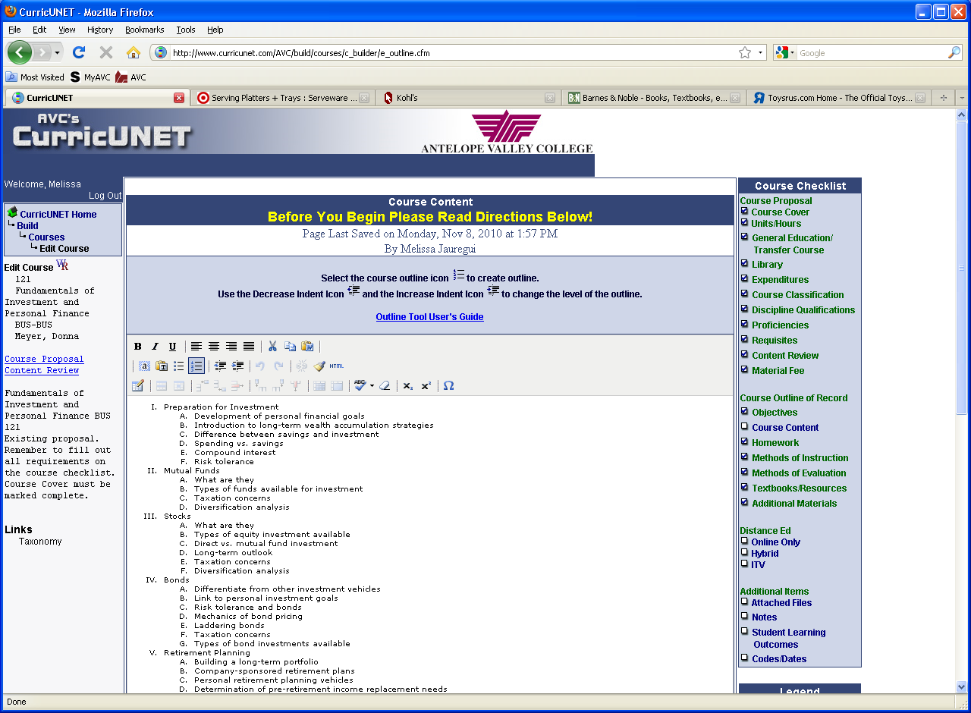
Decrease Indent
Increase Indent
Start Outline Format

